**Lab No 6**

**Task 1**

Write an assembly language program to

1. (a) Display “?”
2. (b) Read two decimal digits whose sum is less than 10
3. (c) Display them and their sum on the next line with appropriate message

*Sample execution*

?27

The sum of 2 and 7 is 9

Run this program and show output

**Code:**

.model small

.stack 100h

.data

msg db 0AH, 0DH, 'SUM of two numbers is : $'

.code

main proc

mov AX, @data

mov DS, AX

mov AH, 2

mov DL, '?'

int 21h

mov AH, 1

int 21h

mov BH, AL

mov AH, 1

int 21h

mov BL, AL

ADD BH, BL

SUB BH, 48

LEA DX, msg

mov AH, 9

int 21h

mov AH, 2

mov DL, BH

int 21h

main endp

end main

**Output:**

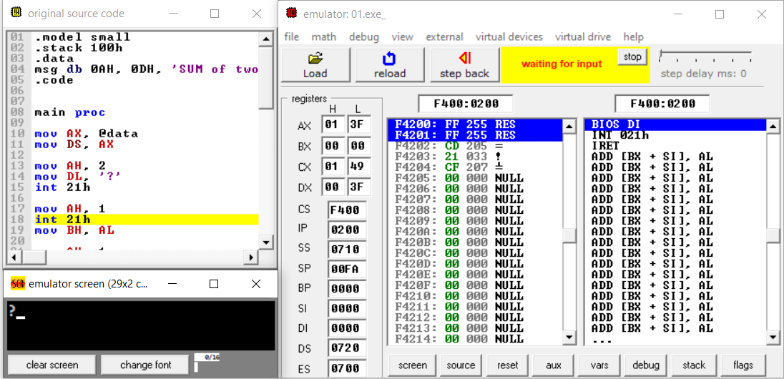

**In-Lab Exercise**

**Task 1**

Write a complete assembly program that converts a user-input lower-case character into corresponding upper-case character. Assemble and emulate the above program in EMU8086. Observe the output of program and explain its working.

**Code:**

.model small

.stack 100h

.data

.code

main proc

mov AX, @data

mov DS, AX

mov AH, 1

int 21h

mov BH, AL

SUB BH, 20h

mov AH, 2

mov DL, BH

int 21h

main endp

end main

**Output:**

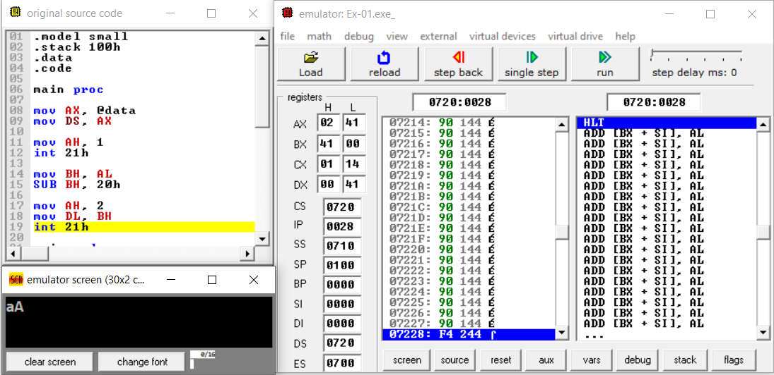

**Task 2**

Write a program, which prints your name on the screen when ‘space’ key is pressed from the keyboard.

Implement using conditional jump instruction.

**Code:**

.model small

.stack 100h

.data

msg db "**AHMED RAZA** $"

.code

main proc

mov AX, @DATA

mov DS, AX

**JUMP:**

mov AH, 1

INT 21h

mov BL, 20h

CMP AL, BL

JE LABEL

JNE JUMP

LABEL:

LEA DX, msg

mov AH, 9

INT 21h

JMP EXIT

**EXIT:**

main endp

end main

**Output:**

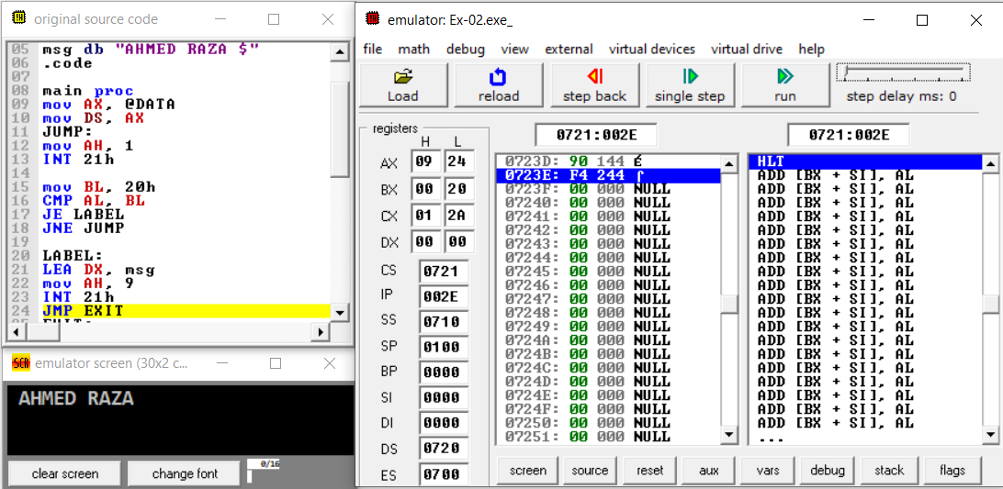

**CONCLUSION:**

In this lab, I have studied about Memory Models, EXE program structure, DOS I/O service routines, INT instruction. I also learn that how to read character input, display a character, read string input and to display string. Further I performed the above-mentioned task. The interesting thing in this lab was that I learned is how to display the output on screen of EMU 8086. I also learn that how to use conditional jump instruction and how to convert lowercase character to uppercase character. And then the instructor evaluated on spot.